**Exercise 1: Setting Up JUnit   
Scenario:**

You need to set up JUnit in your Java project to start writing unit tests.

**1.Created a java project named SampleDemo**  
Below image is the screenshot of what i have done:  
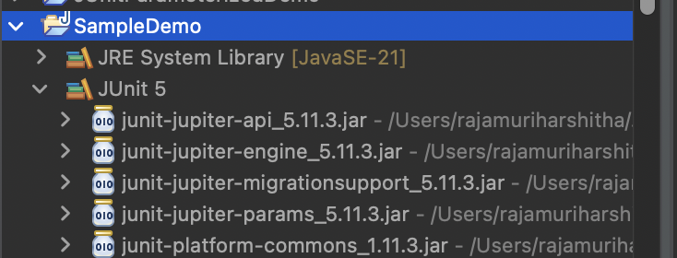

**2.also created a maven project calculator and added dependency in pom.xml file**  
Below image is the screenshot of what i have done:  
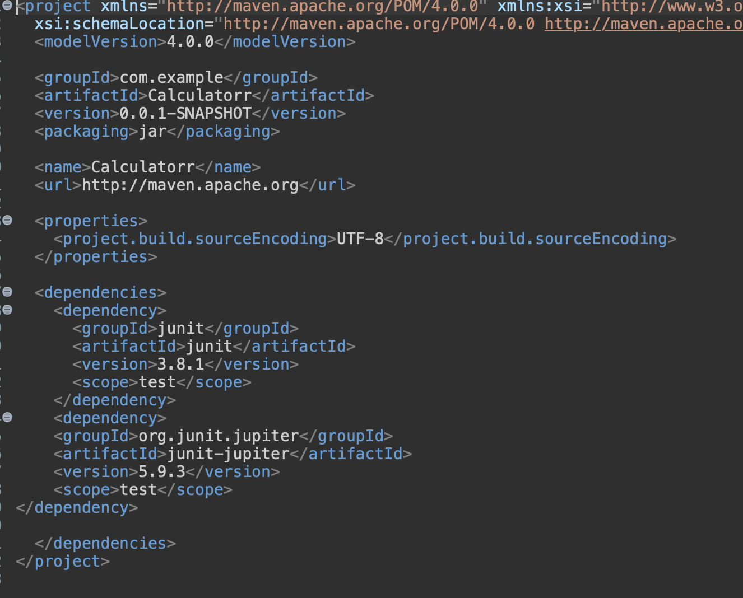  
**3.created a new test class in my java project named CalculatorTest.java**